**Functional Document**

|  |  |
| --- | --- |
| **Application** | NGERP - Centra |
| **Service Bundle** | Purchase Management |
| **Service Request** | View Allocation |

**Description:**

In **Compiere (NGERP - Centra)**, the "**View Allocation**" feature is designed to allow users to manage and track payment and invoice allocations within the system.

**Workflow Process:**

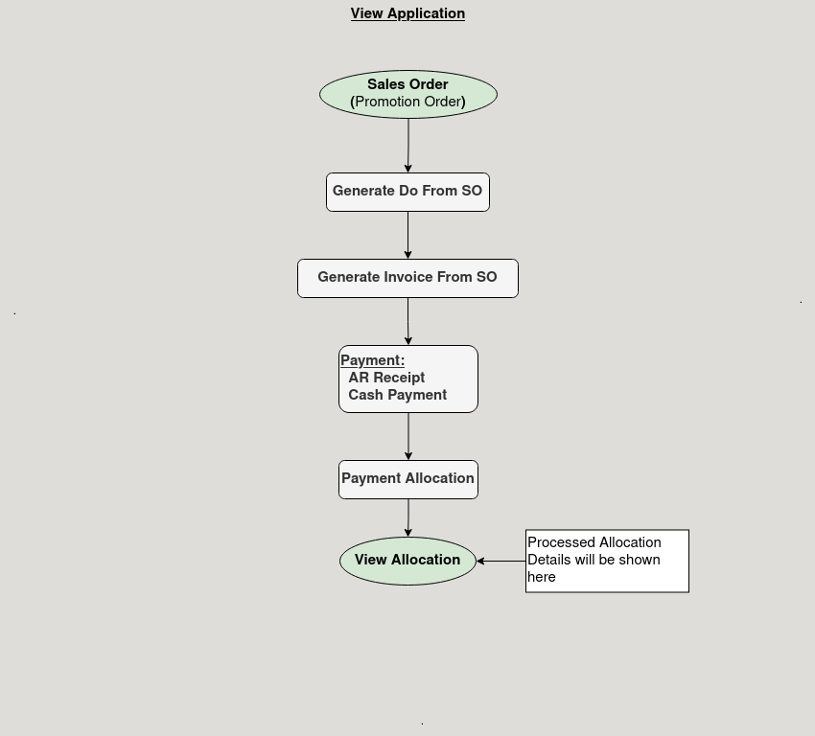

**Business Rules:**

* It is visible in both **HQ** and **ROW**
* In **HQ,** all region allocation details will be shown.
* The system should display allocated transaction details and allocated invoice details in the allocation tab to ensure accurate reporting.
* The system must allow users to export transaction data for further analysis and reporting.
* Transaction reposting should be permitted manually, based on the guidelines in the Posting Logic Sheet.